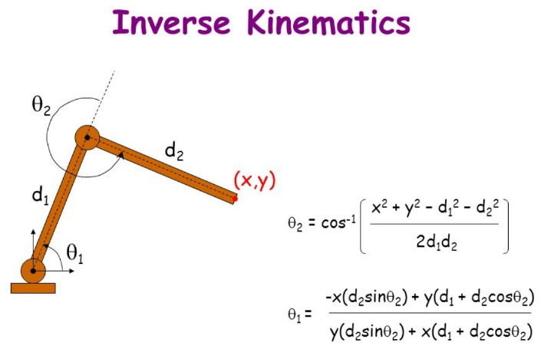
2 dimensional 2 joint inverse kinematics
problem: f(x,y,d1,d2) = Ө_{2,} then derive Ө₁
servo1: origin=(0,0), length=d_{1,} angle=Ө_{1,} servo 2: length=d₂ angle Ө₂

Ө₂ = acos((x²+y²-d₁²-d₂²)/(2*d₁*d₂)) solution set +/- Ө₂ +2kπ
Ө₁ = atan(y/x)-asin(d₂*sinӨ₂/sqrt(x²+y²)) solution set Ө₁ +kπ*

Implementing computation:
exclude divison by zero (when x=0, atan of infinity is pi/2)
use the correct solution (x>0 use second solution in the set ie. Ө₁+π

from math import *
def findangles(x=0.0, y=-0.59, d1=0.3, d2=0.3):
a1=a2=a3=0.0
test=(x*x+y*y-d1*d1-d2*d2)/(2*d1*d2)
if test <-1 or test >1: solutions=0
else:
a2=acos(test)
if x==0: temp=pi/2
else: temp=atan(y/x)
a1=temp-asin(d2*sin(a2)/sqrt(x*x+y*y))
if a2==0: solutions=1
else: solutions=2;a3=temp-asin(d2*sin(-a2)/sqrt(x*x+y*y))
if x>0: a1=a1+3.14# i.e. use the second item in the solution set
return(str(round(a1-0.43,3))+","+str(round(-a2,3)))
a=[]
a.append([0.0, -0.35, 0.3, 0.3]);a.append([-0.1, -0.35, 0.3, 0.3])
a.append([-0.2, -0.35, 0.3, 0.3]);a.append([-0.3, -0.35, 0.3, 0.3])
a.append([0.1, -0.35, 0.3, 0.3]);a.append([0.2, -0.35, 0.3, 0.3])
a.append([0.0, -0.4, 0.3, 0.3]);a.append([0.0, -0.5, 0.3, 0.3])
a.append([0.0, -0.59, 0.3, 0.3])
c=0
# generate motion script
print “#WEBOTS_MOTION,V1.0,motor1,motor4”
for b in a:
print "00:"+"%02d"%(c*3)+":000,x="+str(b[0])+" y="+str(b[1])+","+findangles(b[0],b[1],b[2],b[3])
c=c+1

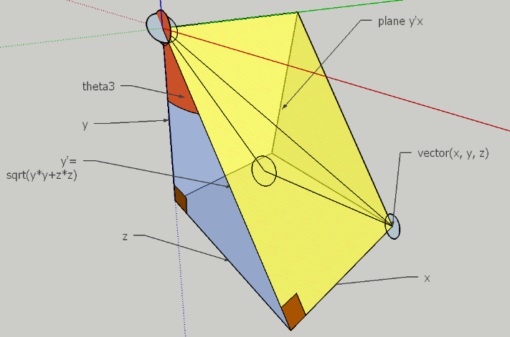
2.5 joint 3 dimensional inverse kinematics

problem: f(x,y,z,d1,d2) = Ө_{2,} then derive Ө₁ , Ө₃
servo0:origin(0,0),length=0, angle=Ө₃, rotates around x axis
servo1:origin=(0,0), length=d_{1,} angle=Ө_{1,}, rotates in y'x plane
servo 2: length=d₂ angle Ө_{2, ,}, rotates in y'x plane

Ө₃= atan(z/y) solution set Ө₃+ kπ/2
use 2d plane y'*x and from 2d equations above derive Ө₂ and Ө₁
y'=sqrt( y² +z²) now substituting y' for y
Ө₂ = acos((x²+y²+z²-d₁²-d₂²)/(2*d₁*d₂)) solution set +/- Ө₂ +2kπ
Ө₁ = atan(y'/x)-asin(d₂*sinӨ₂/sqrt(x²+y²+z²)) solution set Ө₁ +kπ*

from math import *
def findangles(x=0.0, y=-0.4, z=-0.1, d1=0.3, d2=0.3):
ydsq=y*y+z*z;yd=sqrt(ydsq)
if y<0: yd=-yd
a1=a2=a3=0.0
test=(x*x+ydsq-d1*d1-d2*d2)/(2*d1*d2)
if test <-1 or test >1: solutions=0
else:
a2=acos(test)
if x==0: temp=pi/2
else: temp=atan(yd/x)
a1=temp-asin(d2*sin(a2)/sqrt(x*x+ydsq))
if x>0: a1=a1+3.14# i.e. use the second item in the solution set
a3=atan(z/y)
return(str(round(a1-0.43,3))+","+str(round(a3,3))+","+str(round(-a2,3)))

a=[]
a.append([0.0, -0.35, 0.0]);a.append([-0.1, -0.35, 0])
a.append([-0.2, -0.35, 0.0]);a.append([-0.3, -0.35, 0.0])
a.append([0.1, -0.35, 0.0]);a.append([0.2, -0.35, 0.0])
a.append([0.0, -0.4, 0.0]);a.append([0.0, -0.5, 0.0])
a.append([0.0, -0.59, 0.0]);a.append([0.0, -0.35, 0.0])
a.append([0.0, -0.35, 0.1]);a.append([0.0, -0.35, 0.2])
a.append([0.0, -0.35, 0.3]);a.append([0.0, -0.35, -0.1])
a.append([0.0, -0.35, -0.2]);a.append([0.0, -0.35, -0.3])
a.append([0.0, -0.35, -0.2]);a.append([0.0, -0.35, 0.0])
c=0 #generate motion script
print “#WEBOTS_MOTION,V1.0,motor1,motor9,motor4”
for b in a:
print "00:"+"%02d"%(c*3)+":000,x="+str(b[0])+" y="+str(b[1])+" z="+str(b[2])+","+findangles(b[0],b[1],b[2])
c=c+1

Forward Kinematics Now calculate which solutions hold true for our model, using forward kinematics.
2 dimensions, 2 joints:  x = d_{1*}cos Ө₁ + d₂*cos Ө₁+Ө₂  y = d₁*sin Ө₁ + d₂*sin Ө₁+Ө₂ | 3 dimensions, 2.5 joints:  x = d_{1*}cos Ө₁ + d₂*cos Ө₁+Ө_{2,}  y' = d₁*sin Ө₁ + d₂*sin Ө₁+Ө₂  y = y' cos Ө_{3,}  z = -y' sin Ө₃

#improvements in inv kinematics.
#findangles function now casts x,y,z as floats, if x is positive the second solution is used for a1
#findangles function - a3 is measured from negative y so y needs to be inverted

from math import *
def findangles(x,y,z, d1=30, d2=60):
x,y,z=float(x),float(y),float(z)
ydsq=y*y+z*z;yd=sqrt(ydsq)
if y<0: yd=-yd
a1=a2=a3=0.0; test=(x*x+ydsq-d1*d1-d2*d2)/(2*d1*d2)
if test <-1 or test >1: retun(0,0,0)
else:
a2=acos(test)
if x==0: temp=pi/2
else: temp=atan(yd/x)
a1=temp-asin(d2*sin(a2)/sqrt(x*x+ydsq))
a3=atan(z/-y) # invert the y axis due to location of a3
if x<0: a1=a1+pi #use a different solution if x positive
return(a1,a3,a2)

def forward(a1,a2,a3, d1=30, d2=60):
x=(d1*cos(a1))+(d2*cos(a1+a2))
yd=(d1*sin(a1)+d2*sin(a1+a2))
y=yd*cos(a3)
z=-yd*sin(a3)
return(round(x,1),round(y,1),round(z,1))

def test(a,b,c):
print("original coords: x="+str(a)+" y="+str(b)+" z="+str(c))
a=findangles(a,b,c);print("angle(degs) a1="+str(a[0]*30.96)+" a2="+str(a[2]*30.96)+" a3="+str(a[1]*30.96))
b=forward(a[0],a[2],a[1]);print("derived coords: x="+str(b[0])+" y="+str(b[1])+" z="+str(b[2]))
print"=============================================================="

#now test in all 4 quadrants
test(10,-75,0);test(20,-52,10)
test(-20,-62,-10);test(10,52,0)
test(-10,62,0);test(20,-52,10)
test(-20,-62,-10)

OUTPUT
original coords: x=10 y=-75 z=0
angle(degs) a1=-70.5817163203 a2=37.8821618443 a3=0.0
derived coords: x=10.0 y=-75.0 z=0.0
=======================================================
original coords: x=20 y=-52 z=10
angle(degs) a1=-81.4716011396 a2=60.0334282584 a3=5.88203739396
derived coords: x=20.0 y=-52.0 z=10.0
=======================================================
original coords: x=-20 y=-62 z=-10
angle(degs) a1=100.992205796 a2=49.9738745039 a3=-4.95091029298
derived coords: x=-20.0 y=-62.0 z=-10.0
=======================================================
original coords: x=10 y=52 z=0
angle(degs) a1=-4.86842567404 a2=63.8192826663 a3=-0.0
derived coords: x=10.0 y=52.0 z=0.0
=======================================================
original coords: x=-10 y=62 z=0
angle(degs) a1=15.3675237948 a2=53.4326705861 a3=-0.0
derived coords: x=-10.0 y=62.0 z=0.0
=======================================================
original coords: x=20 y=-52 z=10
angle(degs) a1=-81.4716011396 a2=60.0334282584 a3=5.88203739396
derived coords: x=20.0 y=-52.0 z=10.0
=======================================================
original coords: x=-20 y=-62 z=-10
angle(degs) a1=100.992205796 a2=49.9738745039 a3=-4.95091029298
derived coords: x=-20.0 y=-62.0 z=-10.0
=======================================================
>>>

So final algorithm
def findangles(x, y, z, d1=30, d2=60):
x, y, z = float(x), float(y), float(z)
ydsq = y * y + z * z;
test = (x*x + ydsq - d1*d1 - d2*d2) / (2*d1*d2)
if test < -1 or test > 1 or x*x+y*y+z+z<(d1-d2)*(d1-d2):
return(0, 0, 0, 0)
else:
a2 = acos(test)
if x == 0: temp = pi / 2
else: temp = atan(-sqrt(ydsq) / x)#yd = -sqrt(ydsq) i.e. assume yd is negative for now
a1 = temp - asin(d2 * sin(a2) / sqrt(x * x + ydsq))
a3 = atan(z / -y) # invert y axis due to loc of a3
if x <= 0: a1 = a1 - pi #use different solution if x +'ve
if y>=0: #deal with yd as positive
if z<=0: a3= a3 - pi
else: a3 = a3 + pi
return (a1, a3, a2)
The checksums conclude:
When X is negative use second solution for Ө1 (i.e Ө1+pi)
When Y is positive: If Z>0 use Ө3+pi, if Z<=0 use Ө3-pi
Oher wise you can use first solution for Ө1 , Ө2 and Ө3 pi

Speeding up caculations
fill a 3d matrix with remdembered calculations (calculate once, read many)

#scipy is limited in not allowing tuples in its sparse data structures
#to overcome this I use a pointer to a list of tuples
#the 0th value in the list will represent Not calculated

from scipy import sparse
m = sparse.dok_matrix((100, 2000), dtype='int16')
list=["Not calculated"]
def add_element((x, y, z), (a,b,c)):
m[x, y + z * 100] = len(list)
list.append((a,b,c))
def get_element(x, y, z):
return list[m[x, y + z * 100]]
add_element([3, 2, 4], [0.15,1.3,-1.57])
add_element([20, 15, 7], [1.2,-3.23,-1.2])
add_element([0, 0, 1], [-1.20,3.22,-1.34])
print get_element(0, 0, 1)[0]
print get_element(3, 2, 4)
print get_element(20, 15, 7)
print get_element(0, 0, 0)
print " This is m sparse:";print m
m=m.tocsr()
sparse.csr_matrix.sort_indices(m)
print " This is m sparse sorted:";
print m
sparse.save_npz("test.npz", m.tocsr(), compressed=True)
OUTPUT
-1.2
(0.15, 1.3, -1.57)
(1.2, -3.23, -1.2)
Not calculated
This is m sparse:
(3, 402) 1
(20, 715) 2
(0, 100) 3
This is m sparse sorted:
(0, 100) 3
(3, 402) 1
(20, 715) 2

Walking gaits in quadrupeds
walking gaits in quadrupeds are cyclical limb movements that can be described by temporal displacement loops which vary from limb to limb.
Gait | Phases (radians) | limbs in same phase
Prance | 0 | 4
Trot | 0,pi (diagonal) | 2
Pace | 0,pi (ipsilateral) | 2
Gallop | 0,?2/pi (front, back) | 2
Walk | 0,pi/2,pi,3*pi/2 | 1
Displacement, time loops
The shape of the displacement time loop and its time period is likely to be the same for all limbs and these 2 variables will fully describe the gait.

f(t)=(x,y); where constants are origin, x displacement, y displacement
skew in all 4 quadrants (x,y for skew point)
maximum x forward = maximum backward displacement
gait height and gait vertical/horizontal displacement are customisable

ideal gait would: maximise x displacement, minimise y displacement

Initial programmatic solution assumed that velocity was approximately the same through-out the cycle only allowing certain aspects such as heights of the curve to be changed– this limits the possible gaits and dynamics so a more complex definition of the displacement-time loop is needed.

Solution
Have a set number of points in time per cycle i.e. 12 and each of them has a 3 dimensional dipslacement this allows for forward, sideways and rotational movements and also for much better dynamic movements where most displaement takes place in a single phase such as jumping, hopping, proncing etc..
this is still not covering all possible gaits as its possible to use limbs differently ie front feet for balnce and back for propulsion or ?limping gaits .

Rotation of quadrupeds
length and width of body are necessary to calculate rotations
Details of model dimensions (for/from Webots)
Legs | Body dimensions
lower leg 116mm  upper leg 70mm | width 70mm  length 180mm (90+45*2)
Actual dimensions
Body: 90mmx70mm
hips: height 45mm, radius 40mm

arm1 shape: height 70mmxradius 20 mm
translation: x-35mm, y 22.5mm

leg group: height 116mmxradius 20 mm (take 5mm off for foot ->> 111
translation: y: 90mm

foot: sphere radius: 10mm
transalation (from middle: y 55.5mm)

joint anchors
hip1:0,0,0
hip2:y=-0.0225 (for opposite front/back legs reverse signs)
knee: 0.035

centre of robot is at O, body w*l
abs servo front left (l/2,-w/2)
rel foot front left (x,z)
abs foot front left => (x+l/2,z-w/2)
abs foot front right => (x+l/2, z+w/2)
abs foot back left => (x-l/2,z-w/2)
abs foot back right => (x-l/2, z+w/2)
now rotate by angle Ө about O:
x' = x cosӨ - y sinӨ
y' = y cosӨ + x sinӨ
def rotate45(x,z, a, w=70, l=180):
z, z,a =float(x), float(z), float(a);ca=cos(a);sa=sin(a)
nx=x+l/2;nz1=z-w/2;nz2=-z+w/2#get absolute coords about origine
x1=nx*ca+nz1*sa;z1=nz1*ca-nx*sa #x1-l/2 and z1+w2 gives the relative coordinates
x2=nx*ca+nz2*sa;z2=nz2*ca-nx*sa #x2-l/2 and z2-w/2 gives the relative coordinates
return( x2-l/2, z2-w/2,x1-l/2,z1+w/2,-x1+l/2,-z1-w/2, -x2+l/2, -z2+w/2)#new leg positions for FR, FL, BR, BL

